KANSAS ACTIVE TRANSPORTATION PLANNING TOOLKIT

# Engagement Tools

The following tools were developed as part of the Kansas Active Transportation Planning Toolkit to support you in your planning effort. Please adapt them to fit the needs of your community. For additional resources, visit the [Kansas Active Transportation Planning Toolkit](https://www.ksdot.org/bureaus/burRail/bike/ATPlanningToolKit.asp) webpage

# Surveys

Surveying the public can provide a wealth of data to help target active transportation efforts toward community needs and desires. They can be conducted in-person at community events or via intercept surveys as well as online (easiest for compiling responses.) Depending on available budget, local staff can choose from a variety of online survey platforms (some commonly used platforms include SurveyMonkey, Alchemer, Typeform, and SurveyPlanet), and Google offers a free software (Google Forms) as well. Sample questions are provided below for you to tailor to your needs.

## Sample survey questions

### How often do you walk to get around?

* Every day
* A few times a week
* A few times a month
* A few times a year
* Never / not applicable

### How often do you bike to get around?

* Every day
* A few times a week
* A few times a month
* A few times a year
* Never / not applicable

### How often do you use a motorcycle or motor scooter to get around?

* Every day
* A few times a week
* A few times a month
* A few times a year
* Never / not applicable

### How often do you use a vanpool or carpool to get around?

* Every day
* A few times a week
* A few times a month
* A few times a year
* Never / not applicable

### How often do you use a taxi, Uber, or Lyft to get around?

* Every day
* A few times a week
* A few times a month
* A few times a year
* Never / not applicable

### How often do you take the bus to get around?

* Every day
* A few times a week
* A few times a month
* A few times a year
* Never / not applicable

### What other method(s) of transportation do you use to get around? How often do you use this method(s)?

* Write in

### Please rank which aspect are most important to your community for building a safe and connected transportation network on a scale of 1-4 with the most important being 1 and the least important being 4.

* Connectivity: Improve infrastructure that connects important destinations
* Safety and comfort: Build a safer and more comfortable walking and biking network
* Maintenance: Maintain what is already there
* Community: Implement new education and outreach programs

### In the past year, which safety problems have you experienced while traveling in Walkville, KS? Select all that apply.

* Crashes or near-misses at intersections
* Street and/or traffic signs are confusing or hard to see
* Sidewalks are missing or do not meet my needs
* Bike lanes are missing or do not meet my needs
* There’s not enough space in the street to walk or bike
* Vehicle travel speeds
* Lack of pedestrian crossing opportunities

### What places would you most like to be able to access while walking or cycling on foot or on bike? Select up to three.

* Parks
* Grocery Store or convince store
* Trails
* Schools
* Shopping and restaurants
* Libraries
* Community events
* Entertainment
* Places of worship
* Government services
* Medical facilities and services
* Employment areas
* Transit (bus stops, train stations, etc…)
* Other

# Press releases

Local media coverage can help promote engagement opportunities as well as final plan recommendations. Sharing press releases at critical milestones in the process (ex: project launch, public meeting/outreach activities, and draft/final recommendations) can grow awareness and help build support for active transportation efforts.

## Sample Press Release

For Immediate Release [Date]

Contact: [Project Manager] [Phone Number]

### Launching City of Walkville’s Active Transportation Plan

*New plan to provide recommendations for pedestrian andbicycle improvements citywide*

**City of Walkville, KS –** The City of X is pleased to announce the launch of the X Active Transportation Plan, a project that willdevelop policy and infrastructure recommendations to improvewalkingandbiking for residents and visitors alike.

“The Active Transportation Plan is an opportunity to make sure that people walking and biking feel safe and comfortable getting to where they need to go” said the City Mayor. “The plan will improve accessibility for everyone, no matter how you choose to travel through our town.”

Due to the COVID-19 pandemic, initial community outreach activities will be held online. Starting today, residents, businesses, employees and other community members are encouraged to visit the project website at CityofXATP.com. Participants can take part in a virtual walking tour of X’s main corridors and share vital information about their experiences walking and biking on city streets.

# Social Media

Like press releases, social media campaigns can boost awareness of the active transportation planning process and encourage public involvement. Local government social media accounts often have limited followings

- encouraging local partners to repost and reshare content will help expand your reach to newer audiences that may not regularly participate in planning processes. Include fun graphics or photos in social media posts when possible, as well as direct links to the project website or online engagement activity. Make sure to check character limits before posting on specific platforms (for example, Twitter limits posts to 280 characters).

## Sample Social Media Post

Do you live, work or spend time in Walkville? Help us shape the future of safe, sustainable, and active transportation in our city - take this 5-minute survey to share how you travel around the city and any challenges you face: [URL]

# Flyer Template

[Header] Be a part of Walkville’s Active Transportation Plan

[Subheader] Help us improve comfort and safety for people walking and biking! [callout] Online Public Meeting

September 23rd at 5:30pm

KANSAS ACTIVE TRANSPORTATION PLANNING TOOLKIT

Safe, reliable, and convenient transportation is essential for everyone who lives in, works in, and visits Walkville. The City of Walkville is developing an Active Transportation Plan that will include recommendations for future policies and infrastructure projects to improve walking, biking, scooting, and skating in Walkville. We need to hear from you - join us for our first Active Transportation Plan online public meeting on September 23rd from 5:30pm-6:30pm. Learn more about the project’s goals and timeline and give feedback on the opportunities and challenges facing people walking and biking in Walkville today.

[callout] Learn more and find instructions on how to join the online meeting at cityofwalkville.org/ATP

5

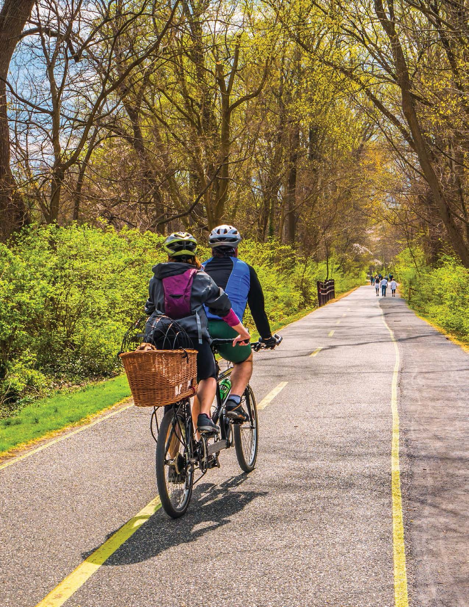

**Be a part of Walkville’s Active Transportation Plan**

## Help us improve comfort and safety for people walking and biking!

**Online Public Meeting September 23rd**

**at 5:30pm**

Safe, reliable, and convenient transportation is essential for everyone who lives in, works in, and visits Walkville. The City of Walkville

is developing an Active Transportation Plan that will include recommendations for future policies and infrastructure projects to improve walking, biking, scooting, and skating in Walkville. We need to hear from you - join us for our first Active Transportation Plan online public meeting on September 23rd from 5:30pm-6:30pm. Learn more about the project’s goals and timeline and give feedback on the opportunities and challenges facing people walking and biking in Walkville today.

Learn more and find instructions on how to join the online meeting at

**cityofwalkville.org/ATP**

[ logos go here ]